VIETNAM NATIONAL UNIVERSITY

INTERNATIONAL SCHOOL


Final Project Report:

DATABASE

TOPIC:

CGV MANAGEMENT SYSTEM DATABASE
CLASS: INS208001

Group members: Vu Hoai Giang - 23070868

Le Doan Tra My - 23070950

Nguyen Thi Anh - 23070932

Pham Hien Anh – 23070981

Ha Noi, 06/2024

Table of Contents

Chapter 1: Introduction: CGV's Customer Management System 2
Chapter 2: Business Description 2
2.1. Introduction of CGV 2
2.2. Business Narratives 2
2.2.1. Defining the problem 2
2.2.2. Proposal of solution 3
2.2.3. User stories 3
2.2.4. Business Rules 3
Chapter 3: System Development 4
3.1. Introduction 4
3.2. ERD 4
3.3. The Relational Schema 6
Chapter 4: SQL statement 8
4.1. Create tables 8
4.2. Insert values 13
4.3. Business questions and SQL solutions 22
Conclusion 31
Appendices 32
Individual contribution 36

Chapter 1: Introduction: CGV's Customer Management System
In today's competitive cinema industry, efficient customer management and booking systems are crucial for success. CGV, a leading cinema chain, requires a robust database to streamline these processes. This project aims to design a comprehensive database tailored to CGV's needs, enabling them to manage customer information and booking data effectively.
The objectives of this system include developing a user-friendly database to store and manage customer details, including contact information, preferences, and loyalty program data; designing a booking system that facilitates movie ticket purchases, seat selection, and reservation management. With this database, we can analyze customer trends, track booking patterns, and gain valuable insights for marketing strategies. This will contribute to improved customer service, increased operational efficiency, and ultimately, a competitive advantage in the cinema industry.
Implementing a new, well-designed relational database solution is a strategic investment that will significantly address the current limitations of CJ CGV's ticket management system. This solution will improve customer service, streamline operations, and provide a competitive edge by allowing data-driven decision-making. By investing in this project, CGV can ensure long-term sustainability and growth in the demanding movie theater market.

Chapter 2: Business Description

2.1. Introduction of CGV
CGV is a major component of CJ Corporation and takes its name from the first letter of the three words: Cultural, Great, and Vital. Founded in South Korea, CGV has expanded globally. CGV is the largest film distributor and cinema operator in Vietnam and ranks as the fifth-largest cinema chain in the world. It provides a large system of cinemas nationwide with high-quality facilities. CGV currently operates 420 cinemas and 3,239 screens in Korea, China, Vietnam, Indonesia, Burma, Turkey, Russia, and the United States. CGV mission: Reaching beyond the mere moved-going visit to the mall, and providing the complete cinematic experience with entertainment and ambiance of the highest order. CJ CGV has created a unique concept of transforming former multiplexes into “Cultureplex”, where customers enjoy the movie and have access to diverse entertainment experiences. CGV implements the latest technology including SCREENX, IMAX, STARIUM, 4DX, and Dolby Atmos as well as completely new and different F&B offerings. CGV offers a world of state-of-the-art facilities, immersive sound systems, crystal-clear screens, and comfortable seating arrangements. Their innovative approach redefines traditional moviegoing, prioritizing customer satisfaction and accessibility through online booking services and loyalty programs. Watching movies at CGV Cinemas is not just about enjoying great films but also about exploring diverse and advanced film culture.

2.2. Business Narratives

2.2.1. Defining the problem
In Vietnam, CGV is the largest cinema system, specializing in screening movies and managing many different cinemas. However, during its operation and development in Vietnam, the company has encountered many challenges due to many shortcomings and a lack of flexibility in the ticket and customer management system. This causes many difficulties and discomfort for customers when lining up to buy tickets at the counter because they have to queue for too long. Furthermore, the ticket management system is not optimized, leading to staff having to process too much raw information, easily leading to confusion in customer information The situation gets worse as CJ CGV faces fierce competition from other competitors in the industry, including foreign and domestic cinema chains. These challenges have created a difficult business environment for CJ CGV, threatening the company's ability to operate profitably and develop sustainably in the long term. Therefore to maintain competitiveness in such a harsh market, CGV must always find reasons for all of these problems, thereby improving customer service, providing classy experiences, and ensuring the appeal of currently screening cinematographic works.

2.2.2. Proposal of solution
To deal with the difficulties and challenges CGV is facing, we propose to build a database called “CGV Management System”. This system can help them store all the data of customers, like the information about their ticket booking (time, movies, cinema branch…), which will facilitate the process of selling tickets online and also offline. It can also contain data on cinemas, movies, and staff of each cinema, which allows the managers and directors of CGV's cinemas to easily gain and manage useful insights for the development of the business, like recording the revenues of movies or allocating and optimizing the human resources. Through this new development, we hope it can help improve customer experience, enhance staff efficiency, and increase operational effectiveness.

2.2.3. User stories
- For customer:
- As a customer, I want to know detailed information about my favorite films, as well as the type of seats and prices.
- As a customer, I want to buy tickets through the online app so that I don't have to wait in line at the cinema.
- As a customer, I want to know if I can have any discount for being a long-term customer of CGV
- For general manager:
- As a general manager, I want to have a list of staff who work overtime so that I can give rewards or promotions to them
- As a general manager, I want to collect the reviews and complaints of customers about the services or facilities so that I can improve them.
- As a general manager, I want to build a database of staff working previously and currently so that I can manage the turnover rate and control the number of staff to delegate duties
- For front-line staff:
- As a ticket seller, I want a booking system so that I can know the exact reservation information of each customer when they show their customer IDs
- For marketing manager:
- As a marketing manager, I want to know the revenue of different movie genres, so that I can focus on customer tastes
- As a marketing manager, I want to classify customers in the cinema business so that I can accurately forecast the demand

2.2.4. Business Rules
These business rules help our team in designing and analyzing the database:
- Each customer, defined by customer ID, can reserve many tickets.
- Each ticket, defined by ticket ID, is collected by a staff, a staff can collect many tickets.
- Each ticket, defined by the ticket ID, consists of the movie's name, showtime, ID of seats (which also determines the number of rooms), price, and the ID of the staff responsible for that customer.
- Each customer can also have many orders (for food and drink)
- Each order, defined by order ID, is managed by a staff
- Each customer, with different levels of membership cards, can have one discount. A discount can belong to many customers.
- Each room, defined by the ID of the seat, can have many reservations but 1 reservation belongs to only 1 room
- Each movie, defined by the movie's ID, can have many reservations (tickets).
- A cinema can have many rooms and staff, but a staff belongs to only one room

Chapter 3: System Development

3.1. Introduction
From the problem we define above and all of the user stories, our database will be structured with multiple interlinked tables to store and manage various types of data, including:
- Movie information: Movie titles, release dates, showtimes, genre, producers, revenues and reviews. This will provide customers with all the information they need about a movie, and also from this, the manager can track the revenues and the feedback of each film for business purposes.
- Ticket Sales & Reservations: Showtime details, seat selection, pricing information, and payment methods. With this entity, the front-line staff can easily find all the necessary information of each customer without confusion.
- Staff Management: Staff information, roles, contact, salary, and working time. With this entity, the general manager can keep track of the number of staff and also the turnover rate, so that they can find solutions and delegate duties more appropriately.

3.2. ERD
Our entity-relational diagram includes 7 entities (tables) with different attributes as below and types of data as we mentioned above:
- Customer table (Customer_ID, Name, Age, Gender, Telephone, Address, Discount_ID, Feedback)
- Reservation table (Reservation_ID, Movies_ID, Price, Date_and_time, Payment_method, Seat_ID, Customer_ID, Staff_ID)
- Rooms table (Seat_ID, Room_ID, Type_of_seat)
- Movies table (Movies_ID, Movies_Name, Day_of_release, Genre, Nation, Main_character, Revenue, Feedback)
- Staff table (Staff_ID, Seat_ID, Staff_Name, Telephone, Address, Salary, Role, Start_working_day, Work_hour_per_month, Status)
- Orders table (Order_ID, Category, Prices, Quantity, Order_Date, Customer_ID, Staff_ID)
- Discount table (Discount_ID, Discount_Name, Member_card)

According to the business rule:
- Each room can have many reservations, so the relationship between Screening room table and Reservation is one-to-many, with the foreign key of Screening room left at Reservation
- Each room has many staff responsible, but a staff belongs to only one room, so the relationship is one-to-many, with the foreign key of Screening room left at Staff
- Each movie has many reservations (with different time and rooms), but a reservation belongs to only one room (defined by Seat_ID), so the relationship is one-to-many, with the foreign key of Movie table left at Staff table.
- Each customer can have many orders of food and drink (category), but an order (defined by Order ID) belongs to only one customer, so the relationship is one-to-many, with foreign key of Customer left at Order.
- Each order is done by a staff, but a staff can do many orders, so the relationship is one-to-many, with the foreign key of Staff left at Order.
- Each customer has a discount based on their type of member card, a discount (defined by the discount ID) can be given to many customers, so the relationship is one-to-many, with foreign key of Discount table left in Customer table

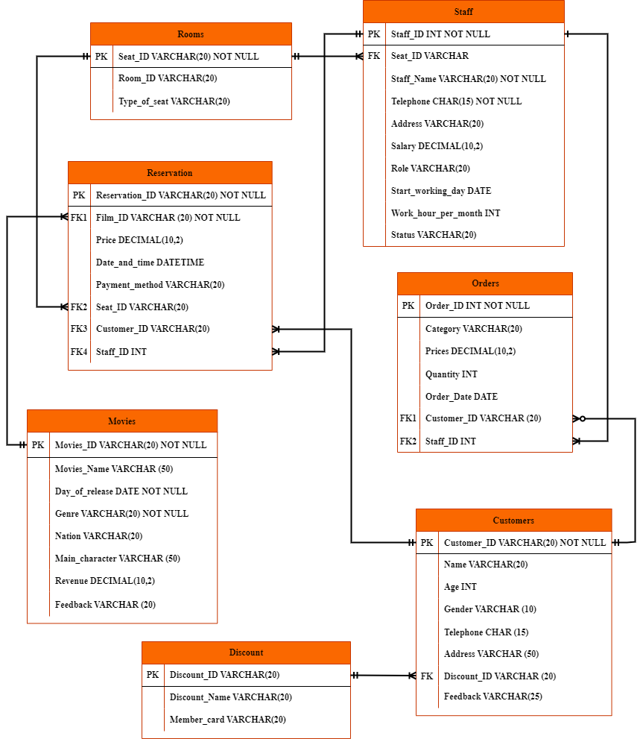

3.3. The Relational Schema
Table Name: Customer

Attribute | Data Type | Primary | Foreign | Constraint
Customer_ID | VARCHAR(20) | ✔ |  | NOT NULL
Name | VARCHAR(20)
Age | INT
Gender | VARCHAR(10)
Telephone | CHAR(15)
Address | VARCHAR(50)
Discount_ID | VARCHAR(20) |  | Discount_ID (Discount)
Feedback | VARCHAR(25)

Table Name: Reservation

Attribute | Data Type | Primary | Foreign | Constraint
Reservation_ID | VARCHAR(20) | ✔ |  | NOT NULL
Fiml_ID | VARCHAR (20) |  | Movies_ID (Movies) | NOT NULL
Price | DECIMAL(10,2)
Date_and_time | DATETIME
Payment_method | VARCHAR (20)
Seat_ID | VARCHAR (20) |  | Seats_ID (Screening rooms)
Customer_ID | VARCHAR(20 |  | Custome_ID (Customers)
Staff_ID | INT |  | Staff_ID (Staff)

Table Name: Discount

Attribute | Data Type | Primary | Foreign | Constraint
Discount_ID | VARCHAR(20) | ✔
Discount Name | VARCHAR(20)
Member_card | VARCHAR(20)

Table Name: Room

Attribute | Data Type | Primary | Foreign | Constraint
Seat_ID | VARCHAR(20) | ✔ |  | NOT NULL
Room_ID | VARCHAR (20)
Type_of_seat | VARCHAR (20)

Table Name: Movies

Attribute | Data Type | Primary | Foreign | Constraint
Movies_ID | VARCHAR (20) | ✔ |  | NOT NULL
Movies_Name | VARCHAR (50)
Day_of_release | DATE |  |  | NOT NULL
Genre | VARCHAR (20) |  |  | NOT NULL
Nation | VARCHAR (20)
Main_character | VARCHAR (50)
Revenue | DECIMAL (10,2)
Feedback | VARCHAR (20)

Table Name: Staff

Attribute | Data Type | Primary | Foreign | Constraint
Staff_ID | INT | ✔ |  | NOT NULL
Seat_ID | VARCHAR(20) |  | Seat_ID (Rooms)
Staff_Name | VARCHAR(20) |  |  | NOT NULL
Telephone | CHAR(15) |  |  | NOT NULL
Address | VARCHAR(20)
Salary | DECIMAL (10,2)
Role | VARCHAR (20)
Start_working_day | DATE
Work_hour_per_month | INT
Status | VARCHAR(20)

Table Name: Orders

Attribute | Data Type | Primary | Foreign | Constraint
Order_ID | INT | ✔ |  | NOT NULL
Category | VARCHAR (20)
Prices | DECIMAL (10,2)
Quantity | INT
Order_Date | DATE
Customer_ID | VARCHAR(20) |  | Customer_ID (Customer)
Staff_ID | INT |  | Staff_ID (Staff)

Chapter 4: SQL statement

4.1. Create tables

- Movie

Create table Movies (
Movies_ID VARCHAR(20) NOT NULL primary key,
Movies_Name VARCHAR (50),
Day_of_release DATE NOT NULL,
Genre VARCHAR (20) NOT NULL,
Nation VARCHAR (20),
Main_character VARCHAR (50),
Revenue DECIMAL (10,2),
Feedback VARCHAR (20),
);

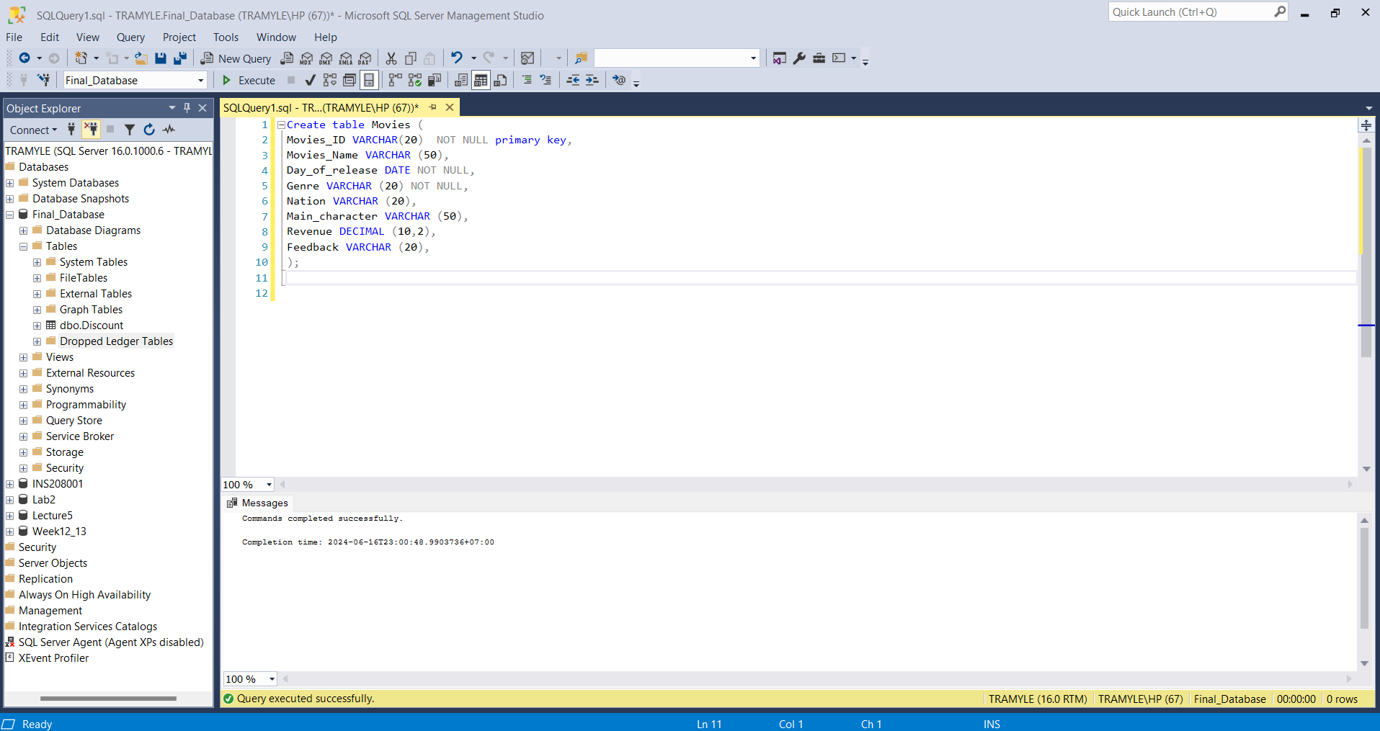

- Room

CREATE TABLE Room (
Seat_ID VARCHAR (20) PRIMARY KEY NOT NULL,
Room_ID VARCHAR(20),
Type_of_seat VARCHAR(20)
);

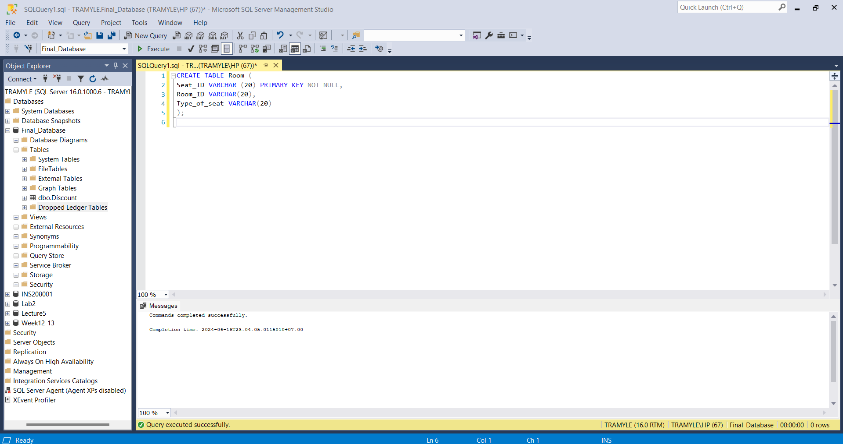

- Discount

CREATE TABLE Discount (
Discount_ID VARCHAR(20) PRIMARY KEY NOT NULL,
Discount_Name VARCHAR(20),
Member_card VARCHAR(20)
);

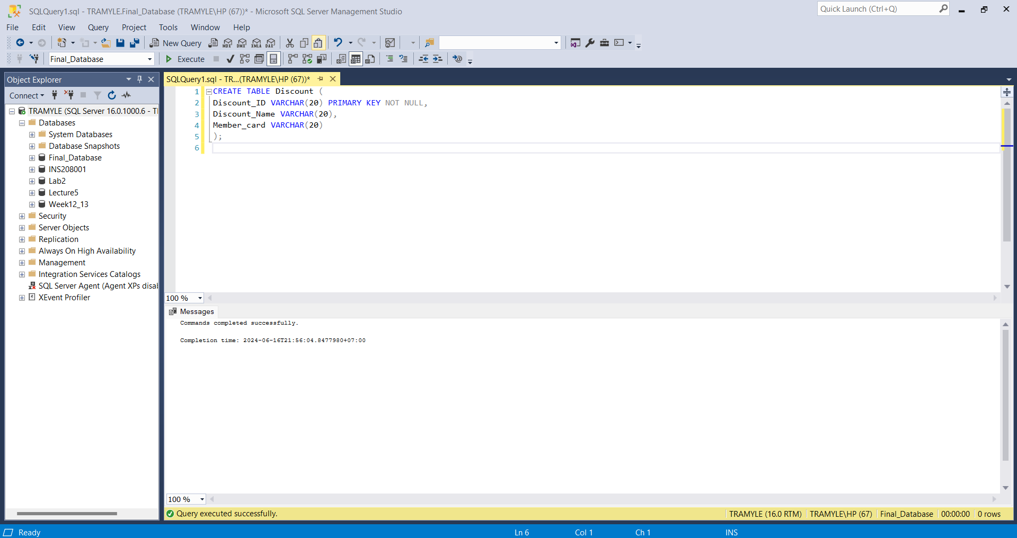

- Staff

Create table Staff (
Staff_ID INT NOT NULL primary key,
Staff_Name VARCHAR (20) NOT NULL,
Telephone CHAR (15),
Address VARCHAR (20),
Seat_ID VARCHAR (20) foreign key references Room (Seat_ID),
Salary DECIMAL (10,2),
Role VARCHAR (20),
Start_working_day DATE,
Work_hour_per_month INT,
Status VARCHAR (20)
);

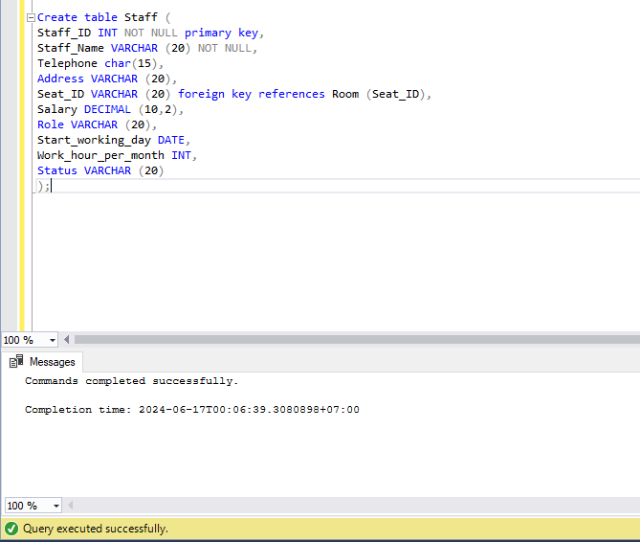

- Customer

CREATE TABLE Customer (
Customer_ID VARCHAR(20) PRIMARY KEY,
Name VARCHAR(20) NOT NULL,
Age INT,
Gender VARCHAR(10),
Telephone CHAR(15),
Address VARCHAR(50),
Discount_ID VARCHAR(20),
Feedback VARCHAR(25),
FOREIGN KEY (Discount_ID) REFERENCES Discount (Discount_ID)
);

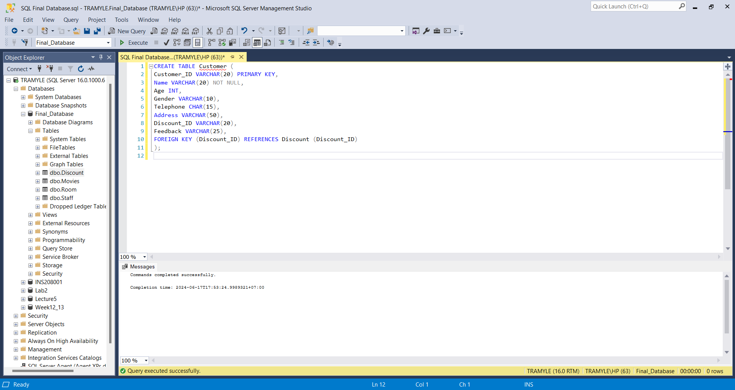

- Orders

Create table Orders (
Order_ID INT NOT NULL primary key,
Category VARCHAR (20),
Prices DECIMAL (10,2),
Quantity INT,
Order_Date DATE,
Customer_ID VARCHAR (20) foreign key references Customer (Customer_ID),
Staff_ID INT foreign key references Staff (Staff_ID)
);

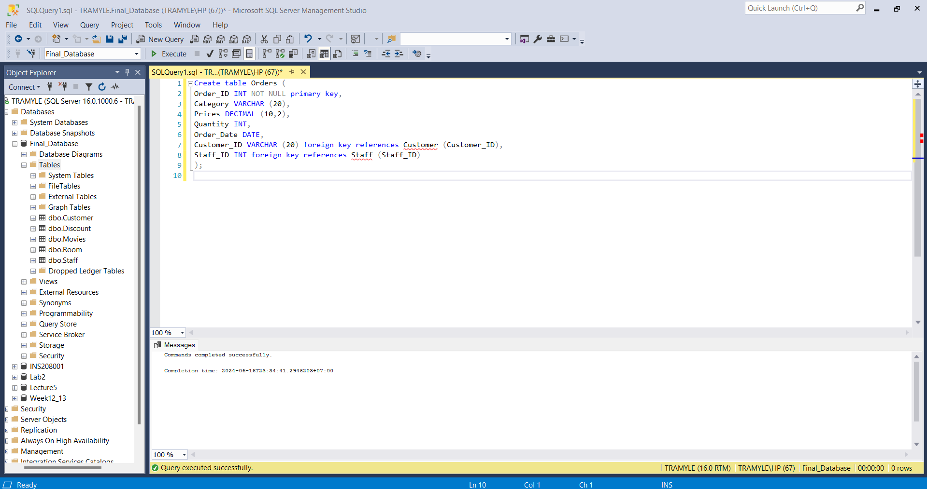

- Reservation

CREATE TABLE Reservation (
Reservation_ID VARCHAR(20) PRIMARY KEY,
Film_ID VARCHAR(20),
FOREIGN KEY (Film_ID) REFERENCES Movies (Movies_ID),
Price DECIMAL (10,2),
Date_and_time DATETIME,
Payment_method VARCHAR(20),
Seat_ID VARCHAR(20),
FOREIGN KEY (Seat_ID) REFERENCES Room (Seat_ID),
Customer_ID VARCHAR(20),
FOREIGN KEY (Customer_ID) REFERENCES Customer (Customer_ID),
Staff_ID INT,
FOREIGN KEY (Staff_ID) REFERENCES Staff (Staff_ID)
);

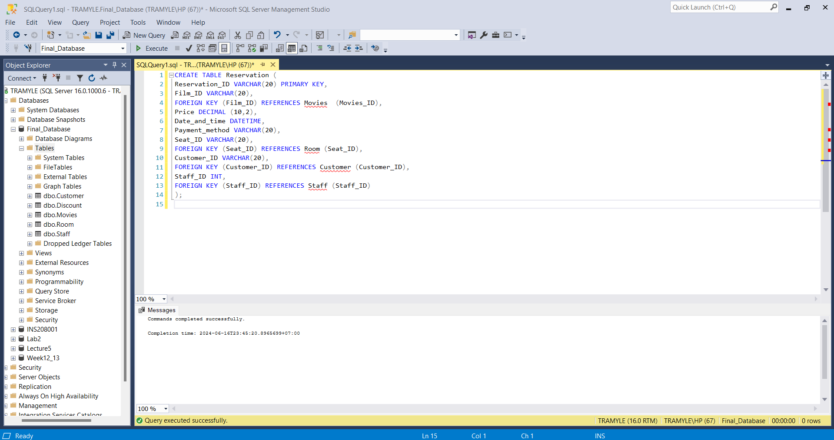

4.2. Insert values
- Movie

Insert into Movies (Movies_ID, Movies_Name, Day_of_release, Genre, Nation, Main_character, Revenue, Feedback)
Values
('SO987', 'Emotional Piece Piece 2', '14-JUN-2024', 'Cartoon', 'America', 'Amy Poehler', 46732000, 'Very good'),
('SO994', 'Grandfathers Investment', '07-JUN-2024', 'Mentality', 'Thailand', 'Billkin', 6854000, 'Very good'),
('SO779', 'Cuu Long Citadel Camp: Surrounding The Citadel', '13-JUN-2024', 'Action', 'China', 'Co Thien Lac', 17623000, 'Bad'),
('SO353', 'DORAEMON', '24-MAY-2024', 'Cartoon', 'Japan', 'Doraemon', 32581054, 'Very good'),
('SO335', 'WATCHERS', '15-JUN-2024', 'Horror', 'America', 'Dakota Fanning', 9425052, 'Good'),
('SO463', 'Life-Swalking Trap', '14-JUN-2024', 'Mentality', 'Korea', 'Gang Dong-won', 35254825, 'Bad'),
('SO644', 'Super Fat Cat', '31-MAY-2024', 'Cartoon', 'America', 'Hannah Waddingham', 41525457, 'Good'),
('SO643', 'EXORCTOR', '15-JUN-2024', 'Horror', 'America', 'Russell Crowe', 33262054, 'Good'),
('SO665', 'Bad Boys: Play Or Get Bored', '07-JUN-2024', 'Action', 'America', 'Will Smith', 28265105, 'Bad'),
('SO981', 'Dieu uoc so 7', '26-APR-2024', 'Mentality', 'Vietnam', 'Thanh Hien', 52659058, 'Very Good'),
('SO456', 'Totto-Chan: The Little Girl At The Window', '31-MAY-2024', 'Cartoon', 'Japan', 'Liliana Ohno', 5866205, 'Good'),
('SO365', 'Womens Souls 2: Revival Ritual', '08-JUN-2024', 'Horror', 'Indonesia', 'Aulia Sarah', 30548920, 'Good'),
('SO123', 'Mong Vuot', '07-JUN-2024', 'Horror', 'Vietnam', 'Tuan Tran', 26920062, 'Bad'),
('SO398', 'Stalker: The Perfect Crime', '30-MAY-2024', 'Mentality', 'Korea', 'Shin Hye-sun', 62058054, 'Good'),
('SO901', 'Furiosa: A Story From Mad Max', '24-MAY-2024', 'Adventure', 'America', 'Anya Taylor-Joy', 8520506, 'Bad'),
('SO023', 'Weird Temple 4', '27-MAY-2024', 'Horror', 'Thailand', 'Bhuripat Vejvongsatechawat', 82005203, 'Very good'),
('SO852', 'Haikyu!!: Battle Of The Scrap Yard', '17-MAY-2024', 'Cartoon', 'Japan', '2D', 15055286, 'Bad'),
('SO159', 'Planet Of The Monkeys: New Kingdom', '10-MAY-2024', 'Adventure', 'America', 'Owen Teague', 62520582, 'Very Good'),
('SO943', 'The Constraint: The Punisher', '26-APR-2024', 'Crime', 'Korea', 'Ma Dong-seok', 72305202, 'Very Good'),
('SO347', 'Mua he dep nhat', '17-JUN-2024', 'Romantic', 'Vietnam', 'Do Khanh Van', 1325205, 'Good')

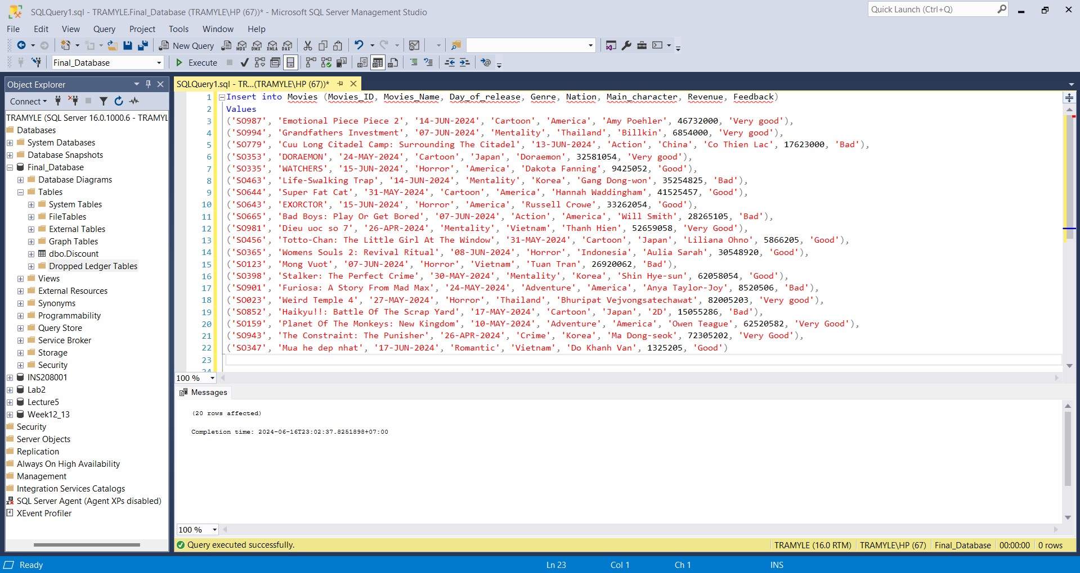

- Room

INSERT INTO Room (Seat_ID, Room_ID, Type_of_seat)
VALUES
('SA01', 'PH1A', 'Standard'),
('SA02', 'PH1A', 'Standard'),
('SB01', 'PH2A', 'Sweet box'),
('SH01', 'PH3A', 'VIP'),
('SH02', 'PH3A', 'Standard'),
('SB02', 'PH2A', 'Standard'),
('SA03', 'PH1A', 'Standard'),
('SH03', 'PH3A', 'Sweetbox'),
('SB03', 'PH2A', 'VIP'),
('SH04', 'PH3A', 'VIP'),
('SH05', 'PH3A', 'Standard'),
('SA04', 'PH1A', 'VIP'),
('SB04', 'PH2A', 'Standard'),
('SA05', 'PH1A', 'Sweetbox'),
('SH06', 'PH3A', 'Sweetbox'),
('SH07', 'PH3A', 'VIP'),
('SB05', 'PH2A', 'Standard'),
('SH08', 'PH3A', 'Standard'),
('SH09', 'PH3A', 'Sweetbox'),
('SB06', 'PH2A', 'VIP')

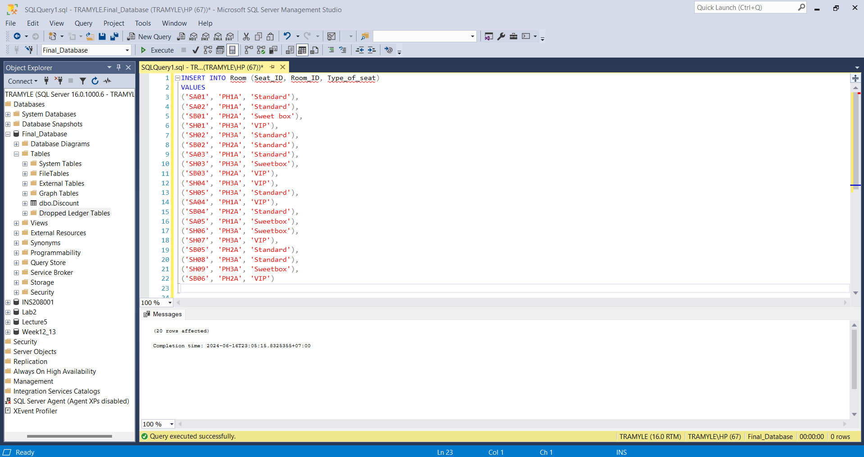

- Discount

INSERT INTO Discount (Discount_ID, Discount_Name, Member_Card)
VALUES
('DS001', '10%', 'Silver'),
('DS002', '20%', 'Gold'),
('DS003', '40%', 'Diamond'),
('DS004', '60%', 'Special')
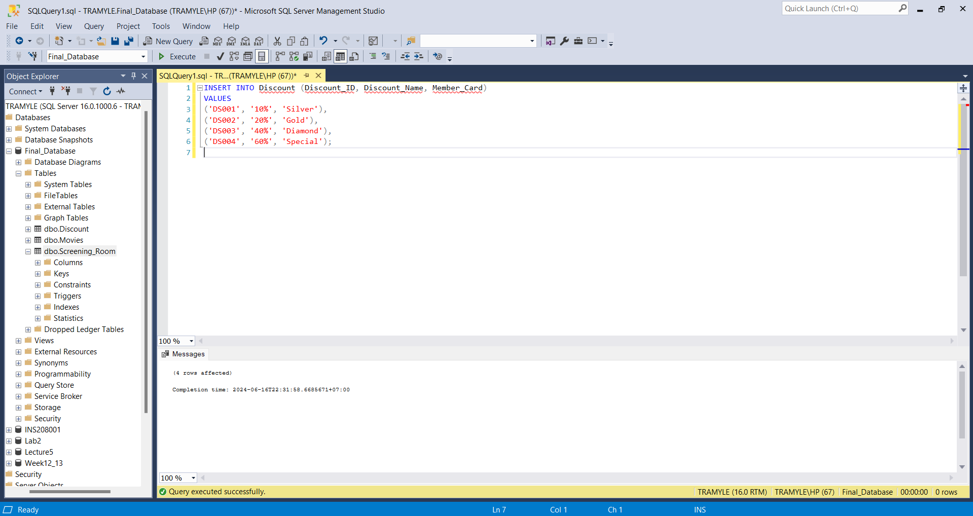

- Staff

Insert into Staff (Staff_ID, Seat_ID, Staff_Name, Telephone, Address, Salary, Role, Start_working_day, Work_hour_per_month, Status)
Values
(240601, 'SA01', 'Nguyen Van A', 0352548925, 'Ba Dinh', 7000000, 'Ticket control', '15-MAY-2023', 55, 'Still working'),
(240602, 'SA02', 'Tran Thi B', 0852005924, 'Dong Da', 10000000, 'Shift Manager', '10-JUN-2023', 60, 'Still working'),
(240603, 'SB01', 'Le Quang C', 0950050506, 'Tay Ho', 15000000, 'Theater Manager', '01-JAN-2022', 70, 'Still working'),
(240604, 'SH01', 'Tran Thi B', 0810222580, 'Long Bien', 7000000, 'Ticket seller', '07-JAN-2022', NULL, 'Retired'),
(240605, 'SH02', 'Pham Minh D', 0354050585, 'Nam Tu Liem', 7000000, 'Ticket control', '20-MAY-2023', 50, 'Still working'),
(240606, 'SB02', 'Do Thi E', 0741025893, 'Bac Tu Liem', 8000000, 'Customer care', '23-MAR-2023', NULL, 'Retired'),
(240607, 'SA03', 'Hoang Van F', 0235874139, 'Cau Giay', 10000000, 'Shift Manager', '25-APR-2022', 57, 'Still working'),
(240608, 'SH03', 'Vu Thi G', 0658741235, 'Dong Da', 8000000, 'Customer care', '05-MAR-2022', 53, 'Still working'),
(240609, 'SB03', 'Ngo Thanh H', 0259314687, 'Hoang Mai', 7000000, 'Ticket control', '17-SEP-2022', 45, 'Still working'),
(240610, 'SH04', 'Bui Thi I', 0782364021, 'Tay Ho', 7000000, 'Ticket control', '29-OCT-2023', 50, 'Still working'),
(240611, 'SH05', 'Dinh Quang K', 0159328756, 'Hoan Kiem', 7000000, 'Ticket seller', '09-MAR-2021', 53, 'Still working'),
(240612, 'SA04', 'Ly Van L', 0328456971, 'Ba Dinh', 9000000, 'Technical staff', '29-SEP-2022', NULL, 'Retired'),
(240613, 'SB04', 'Truong Thi M', 0589321459, 'Hai Ba Trung', 9000000, 'Technical staff', '23-FEB-2021', 60, 'Still working'),
(240614, 'SA05', 'Nguyen Thi O', 0845621795, 'Bac Tu Liem', 7000000, 'Ticket control', '14-MAY-2023', 55, 'Still working'),
(240615, 'SH06', 'Tran Van P', 0486236749, 'Cau Giay', 6000000, 'Theater cleaning', '05-NOV-2021', 70, 'Still working'),
(240616, 'SH07', 'Le Thi Q', 0752036975, 'Thanh Xuan', '10000000', 'HR manager', '02-MAR-2022', 65, 'Still working'),
(240617, 'SB05', 'Pham Quang R', 0147896325, 'Ha Dong', 7000000, 'Ticket control', '26-DEC-2023', 50, 'Still working'),
(240618, 'SH08', 'Do Van S', 0365478925, 'Hoan Kiem', 7000000, 'Ticket control', '20-APR-2022', 49, 'Still working'),
(240619, 'SH09', 'Hoang Thi T', 0987563214, 'Nam Tu Liem', 7000000, 'Ticket seller', '19-JUN-2021', 51, 'Still working'),
(240620, 'SB06', 'Vu Van U', 0782364102, 'Thanh Xuan', 6000000, 'Theater cleaning', '21-MAR-2022', 65, 'Still working')

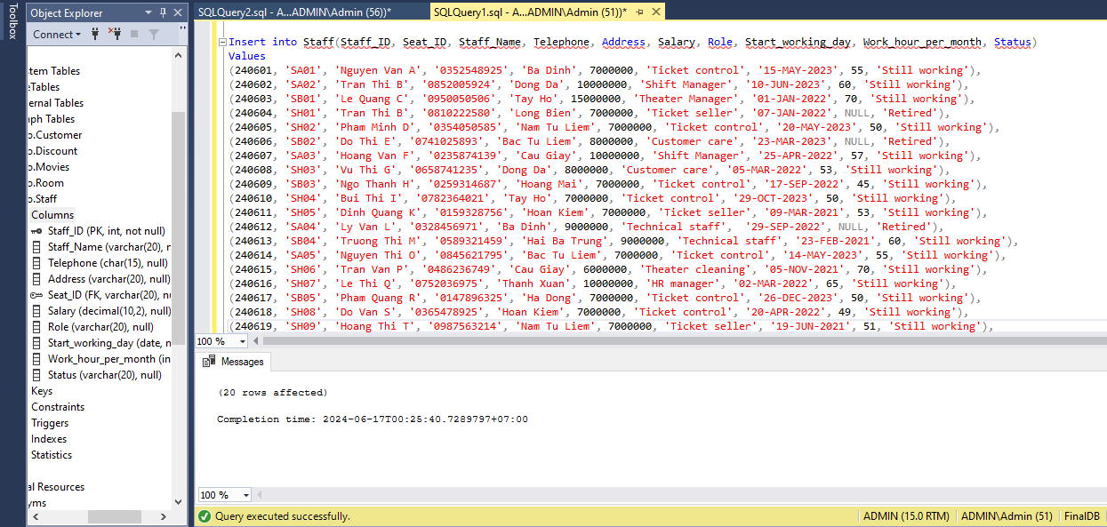

- Customers

INSERT INTO Customer (Customer_ID, Name, Age, Gender, Telephone, Address, Discount_ID, Feedback)
VALUES
('SB0001', 'Winston', 22, 'M', '09854600432', '206 Fondren, Houston, LD', NULL, 'Good'),
('SB0002', 'Anh', 25, 'F', '07725814763', 'An Tien, My Duc, Hanoi', 'DS002', 'Good'),
('SB0003', 'Bich', 25, 'F', '07512458969', 'Te Tieu, My Duc, Hanoi', NULL, 'Very good'),
('SB0004', 'Binh', 45, 'F', '00822536178', '36 Me Tri Thuong, Nam Tu Liem', NULL, 'Very good'),
('SB0005', 'Chau', 35, 'M', '0291248964', 'Tay Ho, HN', 'DS001', 'Bad'),
('SB0006', 'Chi', 22, 'F', '00822544166', '291 Phu My, My Dinh, HN', NULL, 'Good'),
('SB0007', 'Doanh', 45, 'M', '04425874365', 'My Dinh 2, HN', NULL, 'Good'),
('SB0008', 'Sundariya', 55, 'M', '02912258964', 'Ngo 46, Me Tri, Nam Tu Liem, HN', 'DS001', 'Very good'),
('SB0009', 'Lam', 35, 'F', '07745285348', '58 Me Tri Ha, Nam Tu Liem, HN', 'DS002', 'Very good'),
('SB0010', 'Will', 24, 'M', '09854622432', '236 Fondren, Houston, LD', 'DS003', 'Good'),
('SB0011', 'Binh', 43, 'M', '00822536178', '49a Me Tri Ha, Nam Tu Liem, HN', NULL, 'Bad'),
('SB0012', 'Hoa', 32, 'F', '07822255588', '3 Fire Oak, Humble, HN', 'DS004', 'Good'),
('SB0013', 'Chi', 19, 'F', '07712346674', '55a Rice, Houston, HT', NULL, 'Good'),
('SB0014', 'Zelaya', 33, 'M', '00822536178', '22a Stone, Houston, HT', 'DS001', 'Very good'),
('SB0015', 'Sundariya', 24, 'F', '029123568964', 'Ngo 82, Me Tri, Nam Tu Liem, HN', 'DS002', 'Bad'),
('SB0016', 'Linh', 22, 'F', '07745625874', 'Tay Mo, Nam Tu Liem, HN', NULL, 'Good'),
('SB0017', 'Ly', 38, 'M', '04452981425', 'Ngo 14, Me Tri, HN', NULL, 'Good'),
('SB0018', 'Wins', 35, 'M', '09854637432', '14 Fondren, Houston, TH', NULL, 'Bad'),
('SB0019', 'Cook', 22, 'M', '07512458969', 'Kim Lien, Castle, Spring, TH', 'DS003', 'Very good'),
('SB0020', 'Ravindran', 34, 'M', '02912358964', 'Dallas, Houston, HL', NULL, 'Good')
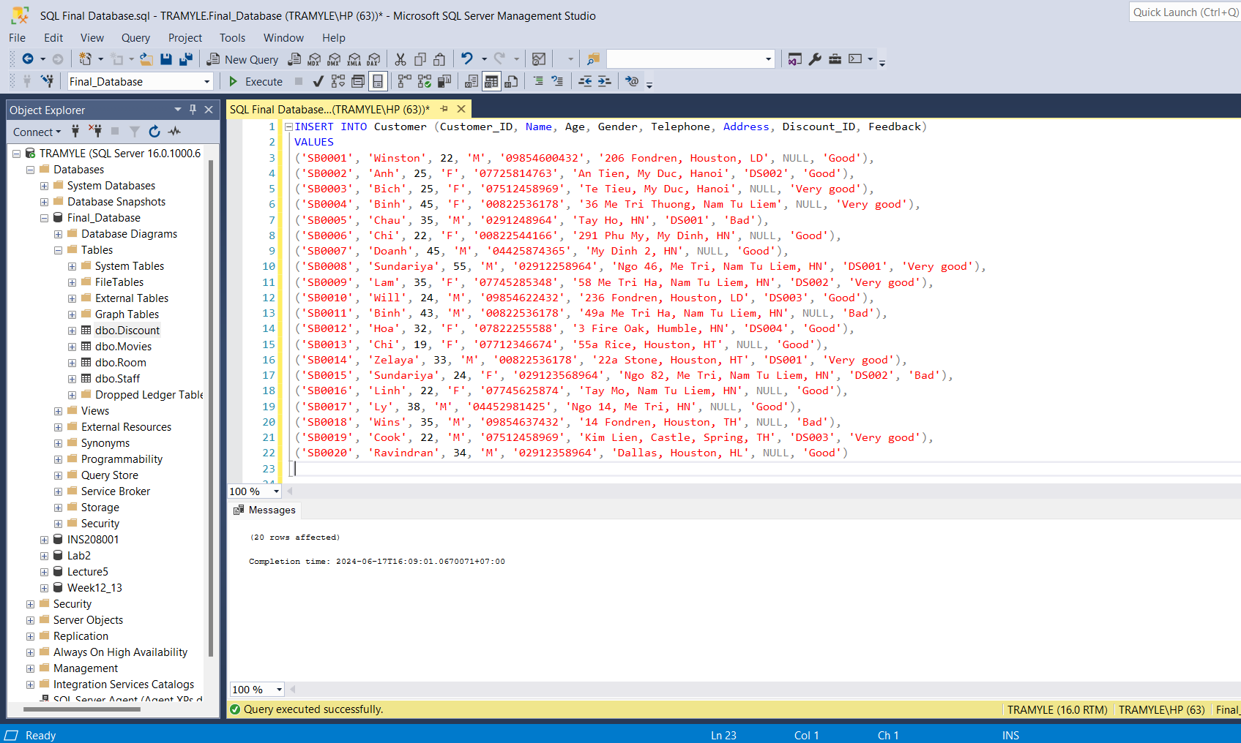

- Orders

Insert into Orders (Order_ID, Category, Prices, Quantity, Order_Date, Customer_ID, Staff_ID)
Values
(062401, 'Popcorn', 50000, 2, '10-MAY-2024', 'SB0001', 240604),
(062402, 'Coca', 20000, 4, '15-MAY-2024', 'SB0002', 240611),
(062403, 'Latte', 35000, 1, '12-JUN-2024', 'SB0019', 240619),
(062404, 'Combo popcorn-cola', 60000, 3, '04-APR-2024', 'SB0001', 240619),
(062405, 'Combo popcorn-latte', 70000, 5, '19-JUN-2024', 'SB0005', 240611),
(062406, 'Coca', 20000, 2, '09-MAY-2024', 'SB0006', 240619),
(062407, 'Coca', 20000, 2, '20-APR-2024', 'SB0020', 240602),
(062408, 'Latte', 35000, 1, '01-JUN-2024', 'SB0008', 240611),
(062409, 'Combo popcorn-cola', 60000, 3, '05-MAY-2024', 'SB0009', 240611),
(062410, 'Combo popcorn-latte',70000, 4, '25-APR-2024', 'SB0010', 240619),
(062411, 'Combo popcorn-cola', 60000, 2, '10-JUN-2024', 'SB0011', 240604),
(062412, 'Popcorn', 50000, 5, '02- JUN-2024', 'SB0016', 240611),
(062413, 'Coca', 20000, 1, '06-MAY-2024', 'SB0013', 240619),
(062414, 'Coca', 20000, 1, '04-APR-2024', 'SB0005', 240604),
(062415, 'Latte', 35000, 3, '2-MAY-2024', 'SB0010', 240611),
(062416, 'Combo popcorn-latte',70000, 7, '23-JUN-2024', 'SB0016', 240619),
(062417, 'Popcorn', 50000, 2, '04-APR-2024', 'SB0017', 240604),
(062418, 'Latte', 35000, 4, '12-MAY-2024', 'SB0014', 240611),
(062419, 'Popcorn', 50000, 5, '27-JUN-2024', 'SB0019', 240604),
(062420, 'Latte', 35000, 1, '09-MAY-2024', 'SB0020', 240619)

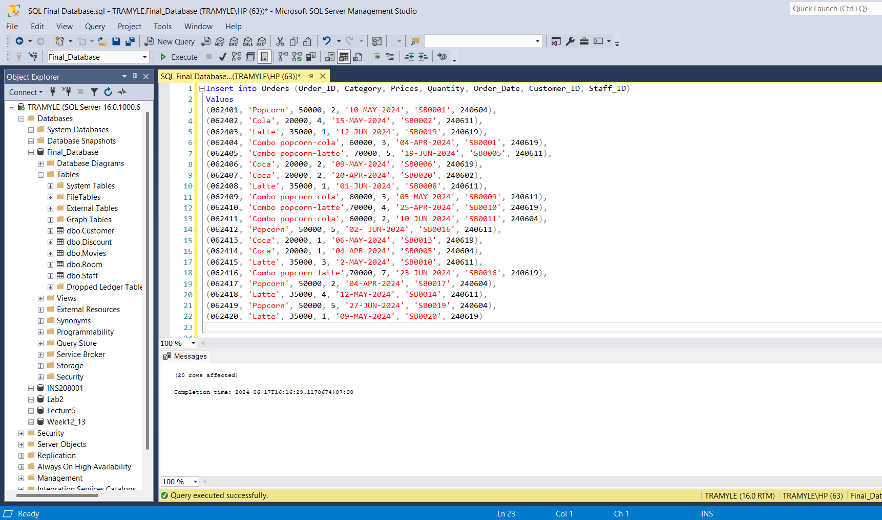

- Reservation

INSERT INTO Reservation (Reservation_ID, Film_ID, Price, Date_and_time, Payment_method, Seat_ID, Customer_ID, Staff_ID)
VALUES
('GV00001', 'SO987', 50000, '2021-05-07 10:10', 'Cash', 'SA01', 'SB0001', '240601'),
('GV00002', 'SO994', 50000, '2021-05-03 9:30', 'Transfer', 'SA02', 'SB0002', '240605'),
('GV00003', 'SO779', 250000, '2021-05-06 10:10', 'Card', 'SB01', 'SB0003', '240609'),
('GV00004', 'SO779', 100000, '2021-05-06 10:10', 'Card', 'SH01', 'SB0004', '240614'),
('GV00005', 'SO987', 50000, '2021-05-07 10:10', 'Cash', 'SH02', 'SB0005', '240617'),
('GV00006', 'SO353', 50000, '2021-05-04 10:10', 'Transfer', 'SB02', 'SB0006', '240618'),
('GV00007', 'SO335', 50000, '2021-05-04 16:30', 'Transfer', 'SA03', 'SB0007', '240610'),
('GV00008', 'SO463', 250000, '2021-05-04 10:10', 'Transfer', 'SH03', 'SB0008', '240605'),
('GV00009', 'SO994', 100000, '2021-05-03 9:30', 'Cash', 'SB03', 'SB0009', '240614'),
('GV00010', 'SO463', 100000, '2021-05-03 13:30', 'Cash', 'SH04', 'SB0010', '240601'),
('GV00011', 'SO644', 100000, '2021-05-07 20:00', 'Card', 'SH05', 'SB0011', '240617'),
('GV00012', 'SO987', 100000, '2021-05-07 10:10', 'Transfer', 'SA04', 'SB0012', '240618'),
('GV00013', 'SO643', 50000, '2021-05-04 10:10', 'Card', 'SB04', 'SB0013', '240609'),
('GV00014', 'SO665', 250000, '2021-05-05 10:10', 'Cash', 'SA05', 'SB0014', '240610'),
('GV00015', 'SO987', 250000, '2021-05-07 10:10', 'Transfer', 'SH06', 'SB0015', '240601'),
('GV00016', 'SO981', 100000, '2021-05-03 10:00', 'Card', 'SH07', 'SB0016', '240609'),
('GV00017', 'SO994', 50000, '2021-05-03 9:30', 'Transfer', 'SB05', 'SB0017', '240617'),
('GV00018', 'SO456', 50000, '2021-05-05 21:00', 'Cash', 'SH08', 'SB0018', '240605'),
('GV00019', 'SO987', 250000, '2021-05-07 10:10', 'Transfer', 'SH09', 'SB0019', '240610'),
('GV00020', 'SO365', 100000, '2021-05-03 10:00', 'Cash', 'SB06', 'SB0001', '240618')

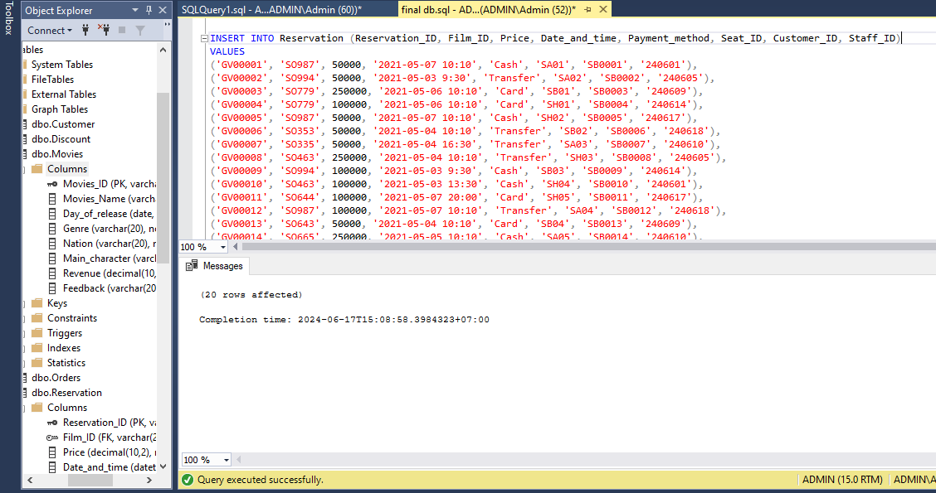

4.3. Business questions and SQL solutions

- Select the top three highest-grossing movies and arrange them in descending order:

Answer: We use Select Top in SQL, and then order it by Revenue from the highest to the lowest (DESC)

select top (3)* from Movies
order by Revenue DESC, Movies_Name DESC;
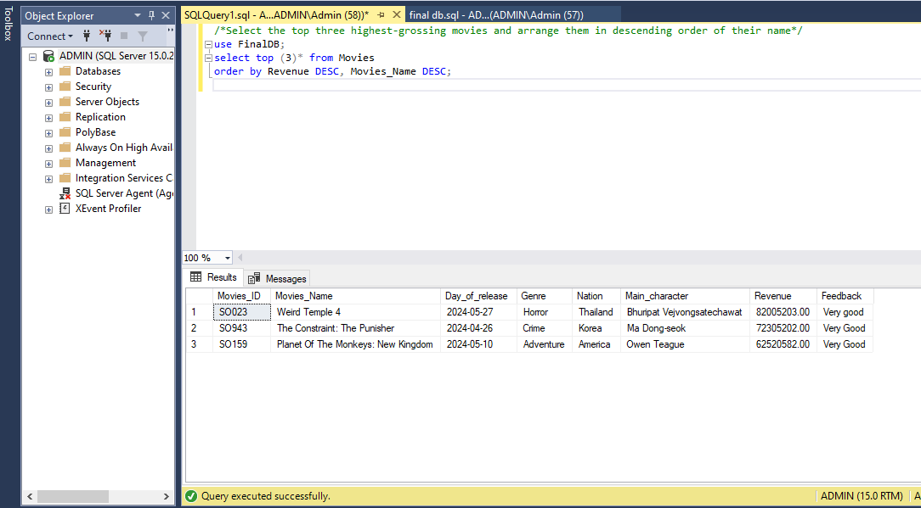
- Determine how many male and female customers have booked seats for each type of screening room.
Answer: Use SUM to count the total number of customers using the CASE ... ELSE statement if 'M' and 'F' then set the value to 1 and count. Additionally, to determine the number of customers in each room, we must JOIN the 3 tables together Customer, Reservation, Room
SELECT H.Room_ID,
SUM (CASE WHEN C.Gender = 'M' THEN 1 ELSE 0 END) as Male_Reservations,
SUM (CASE WHEN C.Gender = 'F' THEN 1 ELSE 0 END) as Female_Reservations
FROM Customer C
JOIN Reservation R ON C.Customer_ID = R.Customer_ID
JOIN Room H ON R.Seat_ID = H.Seat_ID
GROUP BY H.Room_ID;
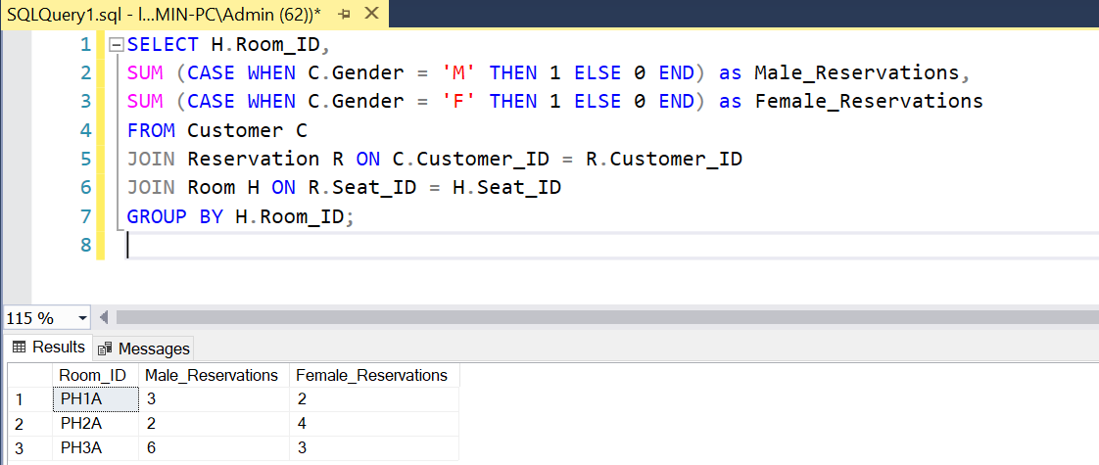
- Which genre of movie is favored by the most customers?
Answer: We create a procedure to determine which genre of movie has the highest number of customers choosing, then we execute the procedure
create procedure FavouriteGenre
as
select Genre, count(Reservation_ID) as Number_of_customer from Movies
inner join Reservation on Reservation.Film_ID = Movies.Movies_ID
group by Genre
Order by Number_of_customer DESC
Go
exec FavouriteGenre;
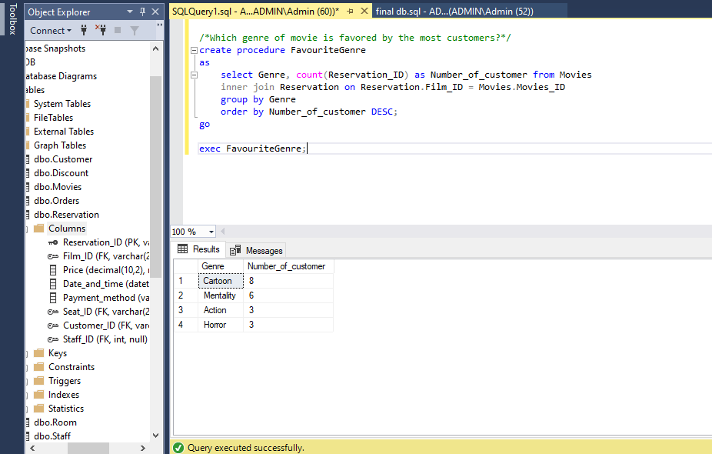
- List the customers' names and the type of seats they chose for movie screenings in room 'PH3A' and calculate the total revenue for each type of seat in that room
Answer: To calculate the total revenue generated by each customer for the different seat types in room 'PH3A, we must JOIN 3 tables: Customer, Reservation and Room to collect the necessary information. The GROUP BY clause returns the results by seat type and customer name, allowing you to see the total revenue each customer contributed to each seat type in room 'PH3A'.
SELECT C.Name, H.Type_of_seat,
SUM(R.Price) as Total_Revenue
FROM Customer C
JOIN Reservation R ON C.Customer_ID = R.Customer_ID
JOIN Room H ON R.Seat_ID = H.Seat_ID
WHERE H.Room_ID = 'PH3A'
GROUP BY H.Type_of_seat, C.Name;
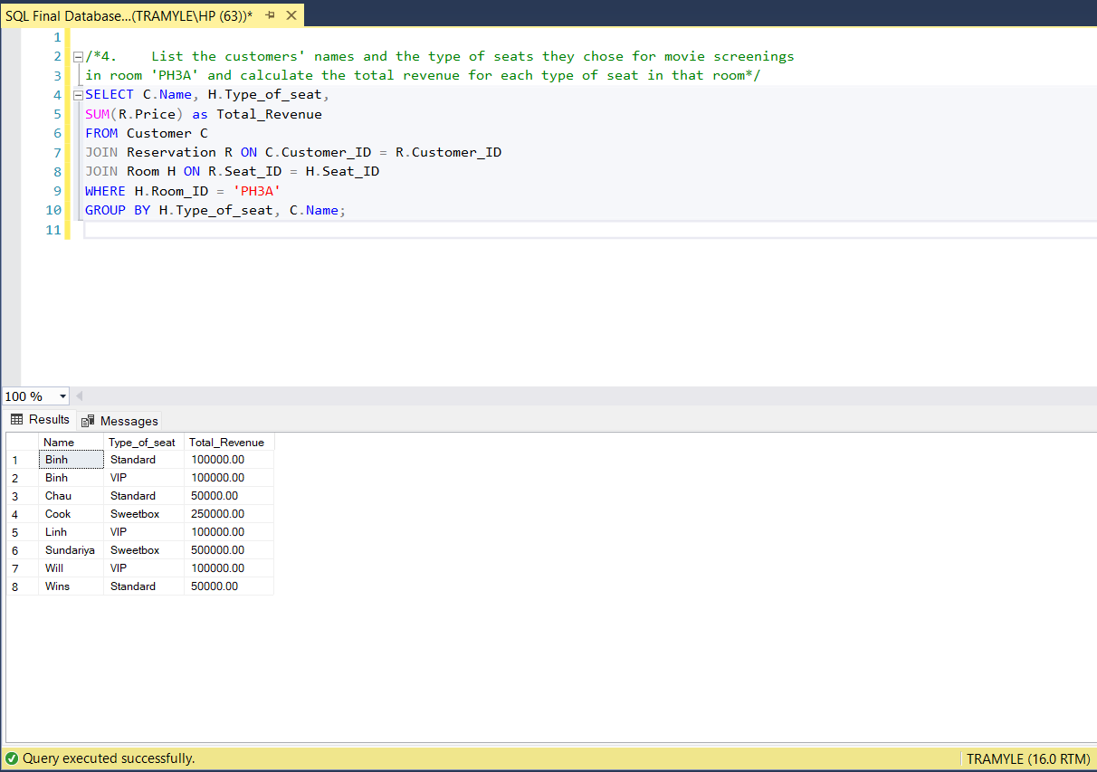
- What are the ages and genders of customers who saw Grandfather's Investment?
Answer: We join the Customer table, the Movie table, and also the Reservation table, and then we select the necessary columns with the condition is the movie’ name is Grandfather's Investment
Select Customer.Name, Customer.Age, Customer.Gender, Reservation.Film_ID, Movies.Movies_Name from Reservation
INNER JOIN Customer on Customer.Customer_ID = Reservation.Customer_ID
INNER JOIN Movies on Movies.Movies_ID = Reservation.Film_ID
where Movies_Name = 'Grandfathers Investment';
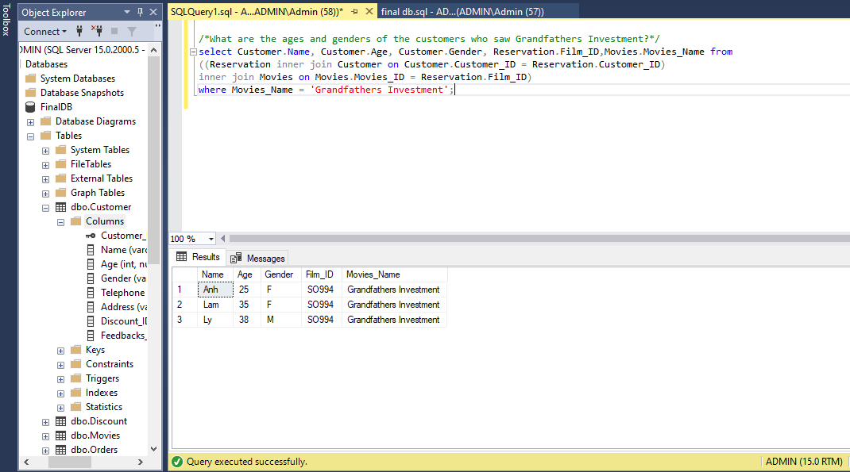
- Which category in food and drink receives the highest sales and in which month?
Answer: We use the expression Prices*Quantity to find the Total sales of each kind of category, then group by category to find out the one with the highest one.
SELECT Category, SUM(Prices * Quantity) AS TotalSales
FROM Orders
GROUP BY Category
ORDER BY TotalSales DESC
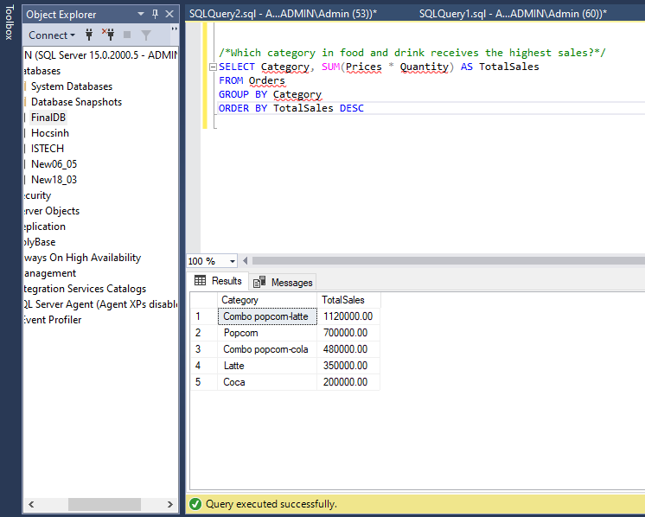
- Find out the type of chair with the highest revenue for each screening room and the total revenue of that type of chair in each room
Answer: We create a stored procedure to get the type of chair with the highest revenue for each room. First, we define a CTE named Revenue_Seat. A CTE is a temporary result set that can be referenced within a SELECT, INSERT, UPDATE, or DELETE statement. This step is to calculate the total revenue for each type of seat in each room. Next, we use the Rank function to assign a rank to each seat type based on its total revenue within each room. Finally selects the seat type with the highest revenue for each room.
CREATE PROCEDURE Highest_Revenue_Seats
AS
BEGIN
WITH Revenue_Seat AS (
SELECT H.Room_ID, H.Type_of_seat, SUM(R.Price) as Total_Revenue
FROM Room H
JOIN Reservation R ON H.Seat_ID = R.Seat_ID
GROUP BY H.Room_ID, H.Type_of_seat )
SELECT Room_ID, Type_of_seat, Total_Revenue
FROM (
SELECT Room_ID, Type_of_seat, Total_Revenue,
RANK() OVER (PARTITION BY Room_ID ORDER BY Total_Revenue DESC) as Revenue_Rank
FROM Revenue_Seat) AS Ranked_Revenue
WHERE Revenue_Rank = 1;
END;
EXEC Highest_Revenue_Seats
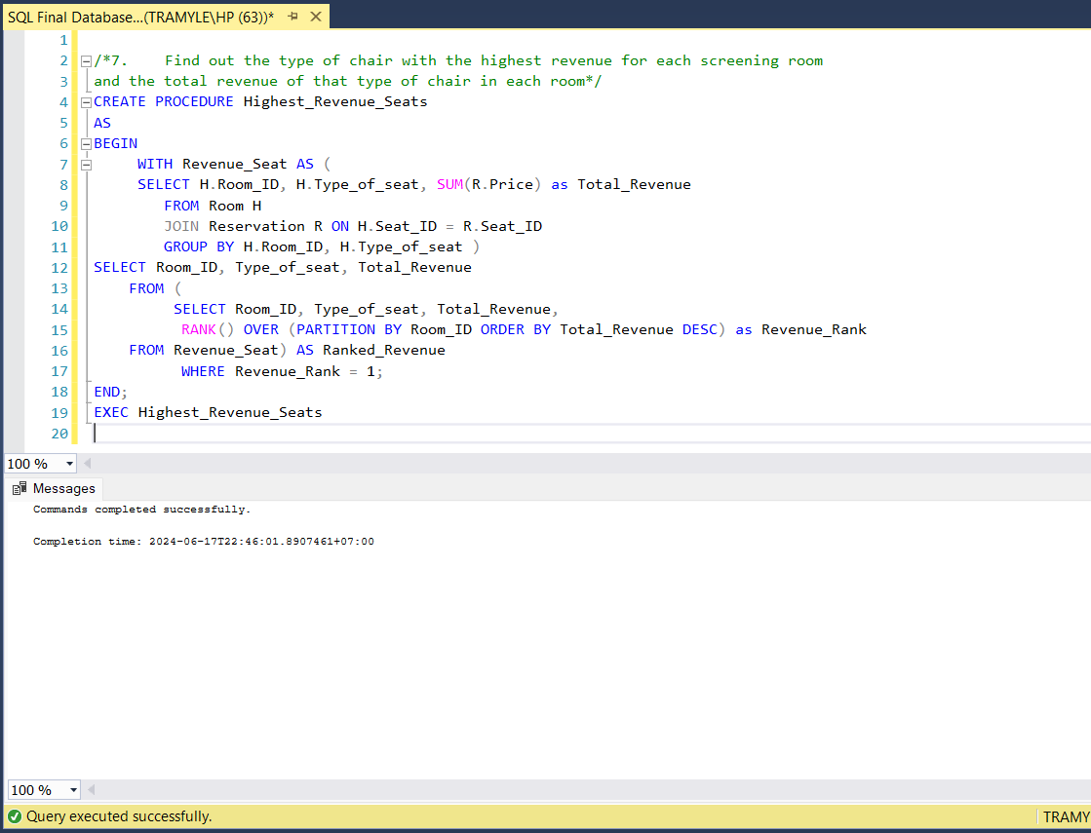
- Use total revenue (price * quantity) and sorted in descending order, if revenue is greater than the amount is 'DAT', if lower than the amount is 'KHONGDAT'. Output results: total revenue, total quantity, KPI
Answer:
- Use SUM function to calculate the total quantity and total revenue
- Use a CASE statement to classify the total revenue (Price * quantity) from the Orders table into different performance categories as Key Performance Indicators (KPIs). If the total amount is 500,000 or more it is classified as 'DAT' and if less than 500,000 it is classified as 'KHONGDAT'. If no condition is met, it defaults to 'Not Applicable', which is short for 'Not Applicable' '.
SELECT Category,
SUM(quantity) AS total_quantity,
SUM(Prices * quantity) AS total_revenue,
(CASE
WHEN SUM(Prices * quantity) >= 500000 THEN 'DAT',
WHEN SUM(Prices * quantity) < 500000 THEN 'KHONGDAT'
ELSE 'N/A'
END) AS KPI
FROM Orders
GROUP BY Category
ORDER BY total_quantity DESC;

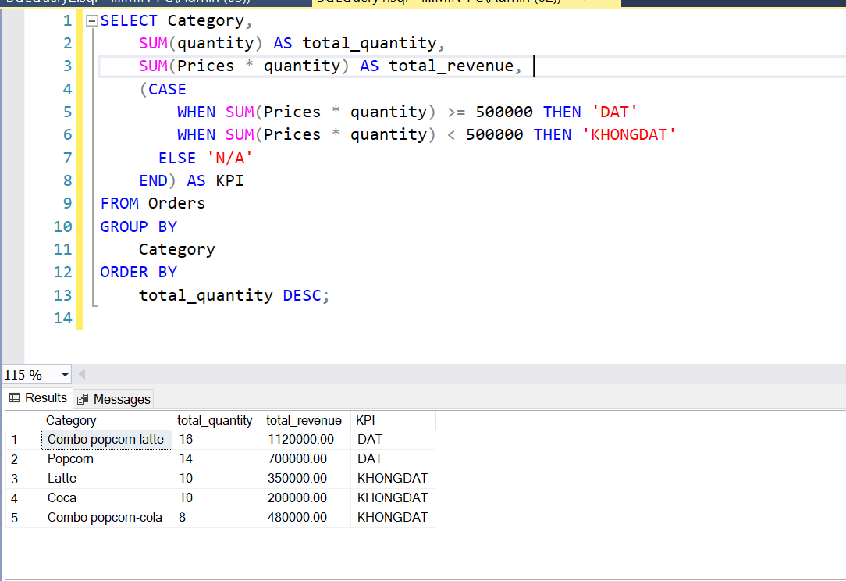
- Calculate the price after being discounted by each customer.
Answer: We select the original price and quantity from the Orders table. We join the Orders table with the Customer table using Customer_ID, the Customer table with the Discount table using Discount_ID. We calculate the discounted price using the discount percentage from the Discount table. We use LEFT JOIN to ensure all orders are included even if there is no corresponding discount.
SELECT Orders.Order_ID, Orders.Category, Orders.Prices AS OriginalPrice, Orders.Quantity, Discount.Discount_Name,
CASE
WHEN Discount.Discount_Name = '10%' THEN Orders.Prices * Orders.Quantity * 0.90
WHEN Discount.Discount_Name = '20%' THEN Orders.Prices * Orders.Quantity * 0.80
WHEN Discount.Discount_Name = '40%' THEN Orders.Prices * Orders.Quantity * 0.60
WHEN Discount.Discount_Name = '60%' THEN Orders.Prices * Orders.Quantity * 0.40
ELSE Orders.Prices * Orders.Quantity
END AS DiscountedPrice,
Customer.Customer_ID,
Customer.Name AS CustomerName
FROM Orders
LEFT JOIN
Customer ON Orders.Customer_ID = Customer.Customer_ID
LEFT JOIN
Discount ON Customer.Discount_ID = Discount.Discount_ID;
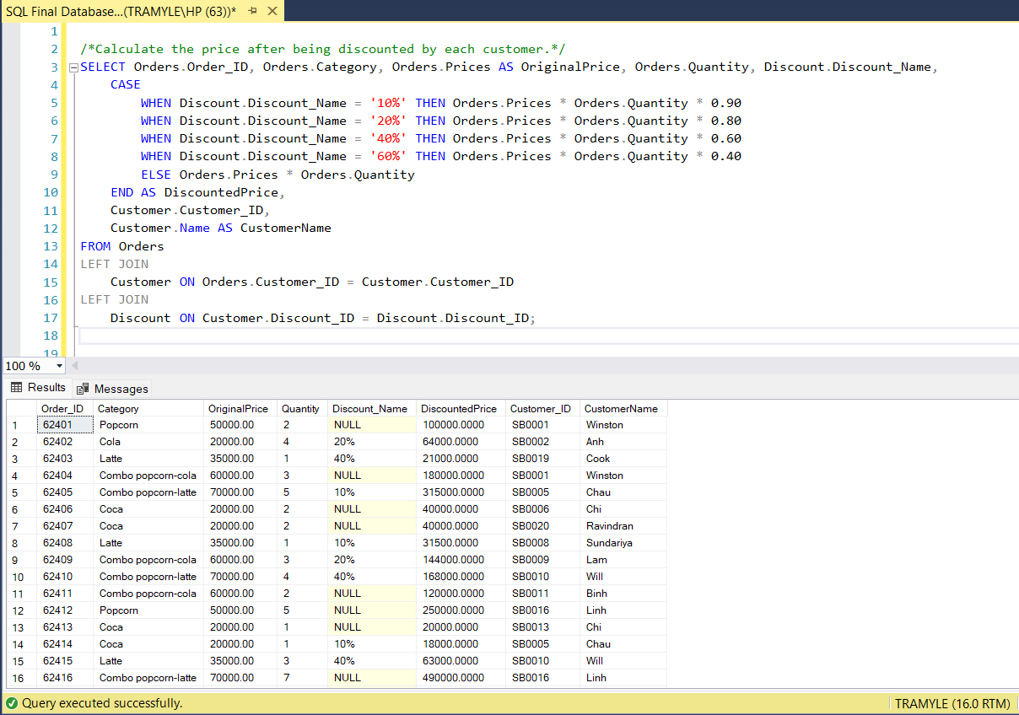

- Select the 3 categories that receive the most orders and have the highest revenue in month.... Output category, revenue, month, quantity.

Answer: We select top 3 categories from the Orders table. To calculate the sum of the prices of the top 3 categories, we use the SUM function and call it revenue. Next, we use the FORMAT function to get the month. The FORMAT function is used to change the data type and format of time and numbers. The SUM of quantity calculates all the quantities of the top 3 categories. Using ORDER BY function to sort in descending order of sum of revenue and sum of total_quantity
SELECT TOP 3 category,
SUM(prices) AS revenue,
FORMAT(Order_date, '04') AS month,
SUM(quantity) AS total_quantity
FROM Orders
WHERE FORMAT(Order_date, '04') = '04'
GROUP BY category, FORMAT(Order_date, '04')
ORDER BY revenue DESC, total_quantity DESC;
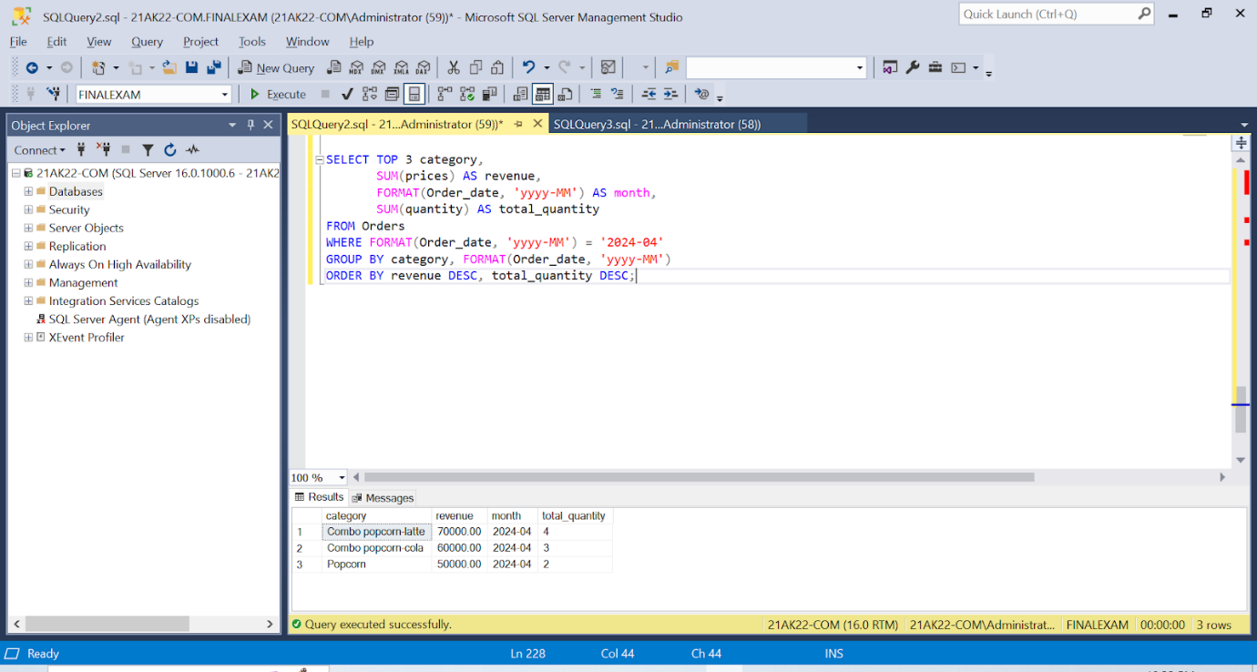

- Select the staff and divide them into three groups: Need warning (if working hour per month < 50), No bonus (if working hour per month between 50 and 55), Need bonus (if working hour per month > 55)
Answer: We create a stored procedure so that we can use this code again: Using function Case with three conditions and separating the retired staff.
create procedure GetStaffReward
as
begin
select Staff_ID, Staff_Name, Role, Work_hour_per_month,
case
when Work_hour_per_month < 50 then 'Need warning'
when Work_hour_per_month between 50 and 60 then 'No reward'
when Work_hour_per_month > 60 then 'Have reward'
else 'Retired'
end as Reward
from Staff
order by Reward
end;
exec GetStaffReward;

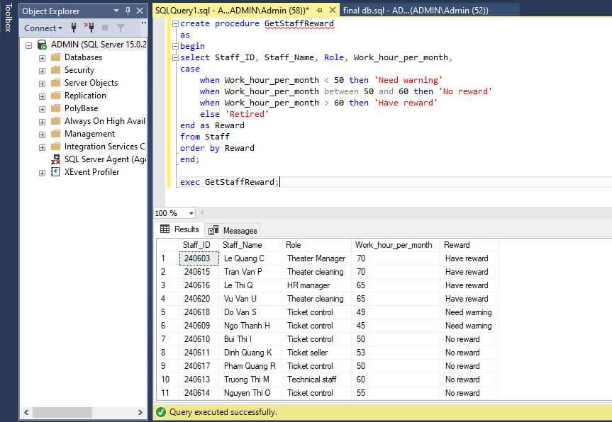

Conclusion
In conclusion, creating an analysis table of data related to the remaining problems from competing with other competitors helps CJ CGV to partly solve the situation that hinders the development of cinemas. And from there, we can come up with specific strategies and update the trend situation to help us understand the needs of each customer group by age, helping us become sustainable and attract customers from everywhere. The collected data also proves that, if we solve the remaining problems in management and development and give the right direction for that development, bringing CGV to the international level is not difficult.

Appendices

Table Movies
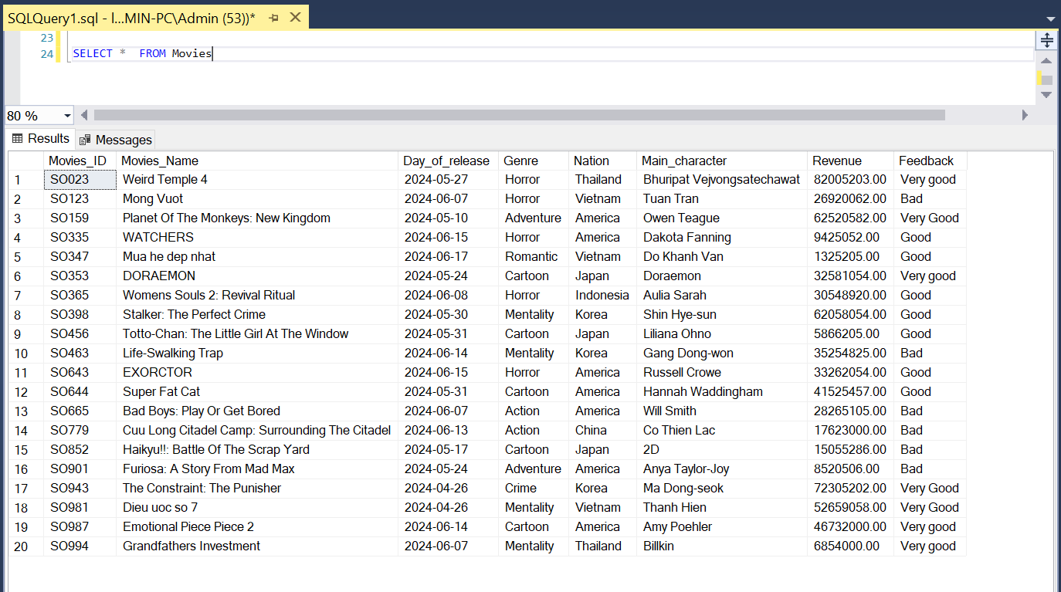

Table Room
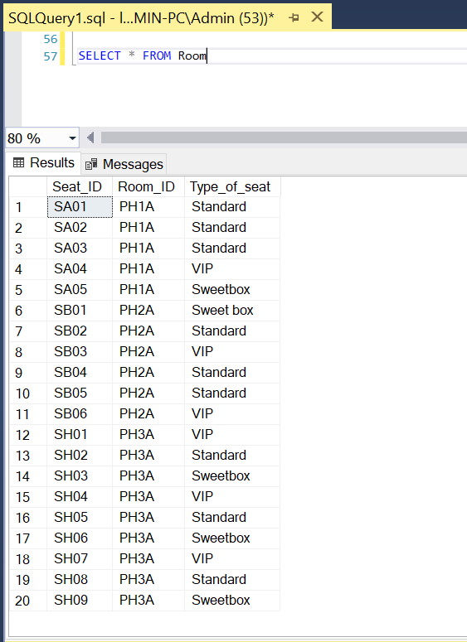

Table Discount
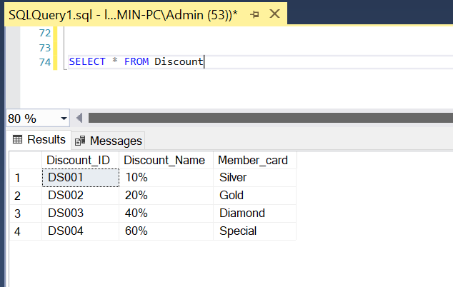

Table Staff
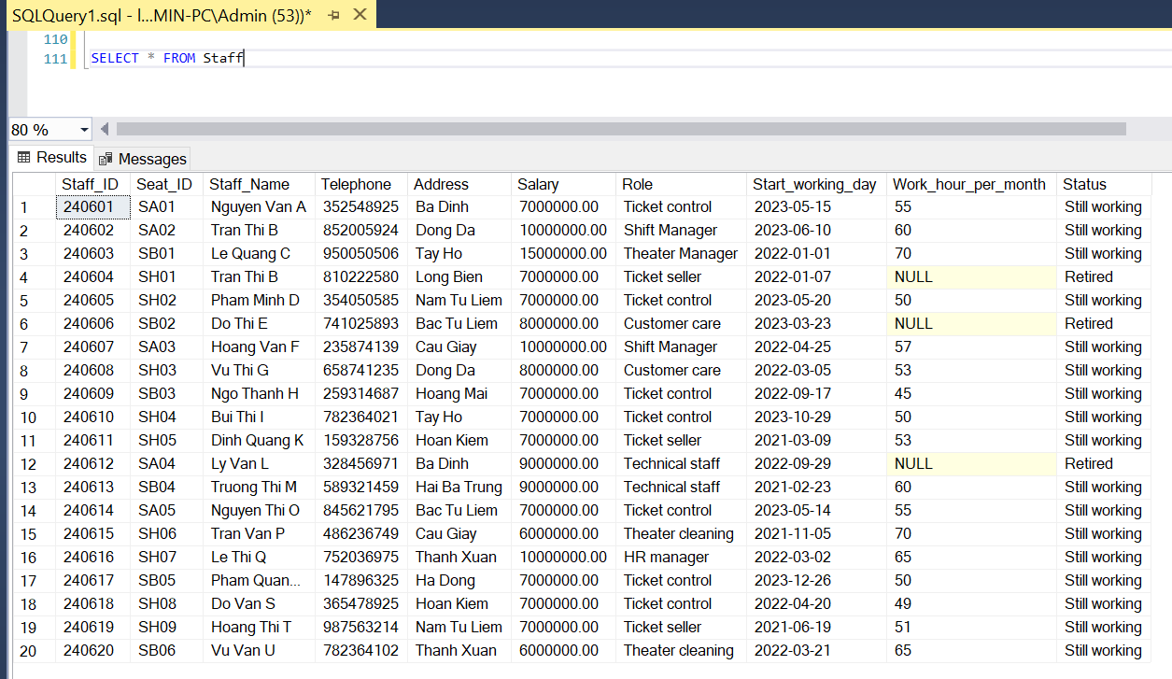

Table Customer
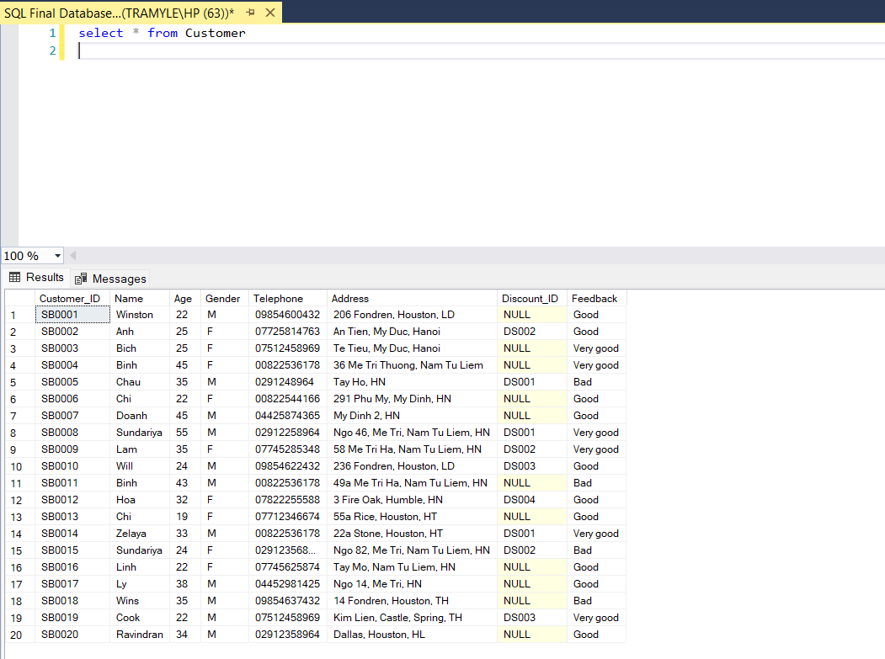

Table Orders
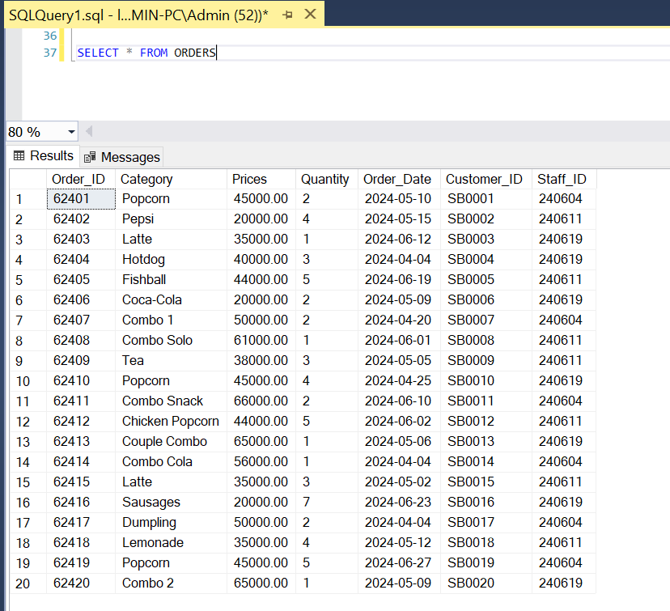
Table Reservation
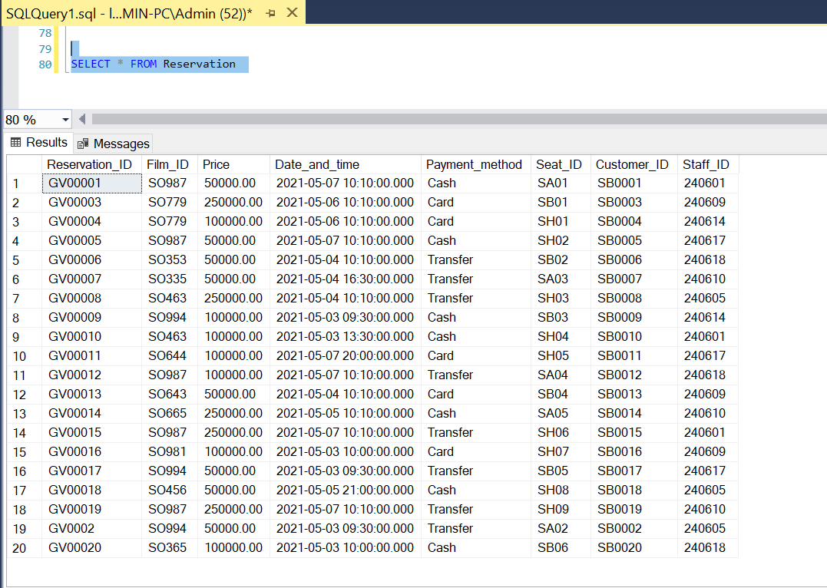

Individual contribution

Name | Student ID | Assigned work | Contribution
Vũ Hoài Giang (Leader) | 23070868 | Create worklist  Introduction to ERD  Create procedures and functions  Formatting the report  Create and solve business questions | 100%
Phạm Hiền Anh | 23070981 | Create User stories  Create and solve business questions  Create PowerPoint  Conclusion | 100%
Nguyễn Thị Ánh | 23070932 | Company's Problem  Create Relational Schema  Create data and code for Customer, Reservation, Room, and Discount tables  Create and solve business questions | 100%
Lê Đoàn Trà My | 23070950 | Introduction  Overview of the company  ERD diagram  Create data and code for Movie, Staff, and Order tables  Formatting the report | 100%

